### 

### SPREADSHEET PROJECT

ADVANCED SOFTWARE DEVELOPMENT

CS-525

**GROUP MEMBERS:**

#1. REDAE MENGSTEAB 15

#2. FNAN EYASU 08

#3. TOMAS MELAKE 22

#4. MOHAMED SAUD 14

ADVISOR PROFESSOR FRANCIS MOSSE

JULY 2019

DESIGN PATTERNS FOR SPREADSHEET PROJECT

|  |  |  |
| --- | --- | --- |
| **Requirements** | **Best Pattern** | **Reasons/Features obtained** |
| Abstract Class Cell, String Cell,  String Value, Equation classes are required | Factory method | Instances of the concrete class (Domain class) |
| Abstract Class Cell, String Cell,  String Value, Equation classes are required | Façade design pattern | Since factory method is a feature of the façade design pattern for reducing coupling between client and domain class and hiding complexity of the system |
|  |  |  |

SPREADSHEET’S SPRINTS - APPLICATION IN JAVA

**Sprint #1 UML DIAGRAM (CLASS DIAGRAM)**

**# Application**

**# Cell**

**# Sheet**

**# Content**

**# Number**

**# String**

**# Expression**

**# Position**

**#Content Factory**

**Sprint #2**

**# Application**

**# Cell**

**# Sheet**

**# Content**

**# Number**

**# String**

**# Expression**

**# Position**

**#Content Factory**

**# Reference**

**Sprint #3**

**# Content Factory**

**# Binary Operator**

**# Add**

**Sprint #4**

**# Subtract**

**# Multiply**

**# Divide**

**Sprint #5**

**# Read formulae**

**# Parse Number**

**Sprint #6**

**# Parse Cell syntax (square brackets)**

**Sprint #7**

**# Parse References to Cells**

**Sprint #8**

**Deal with parenthesis**

SPRINT #1 UML DIAGRAM (CLASS DIAGRAM)

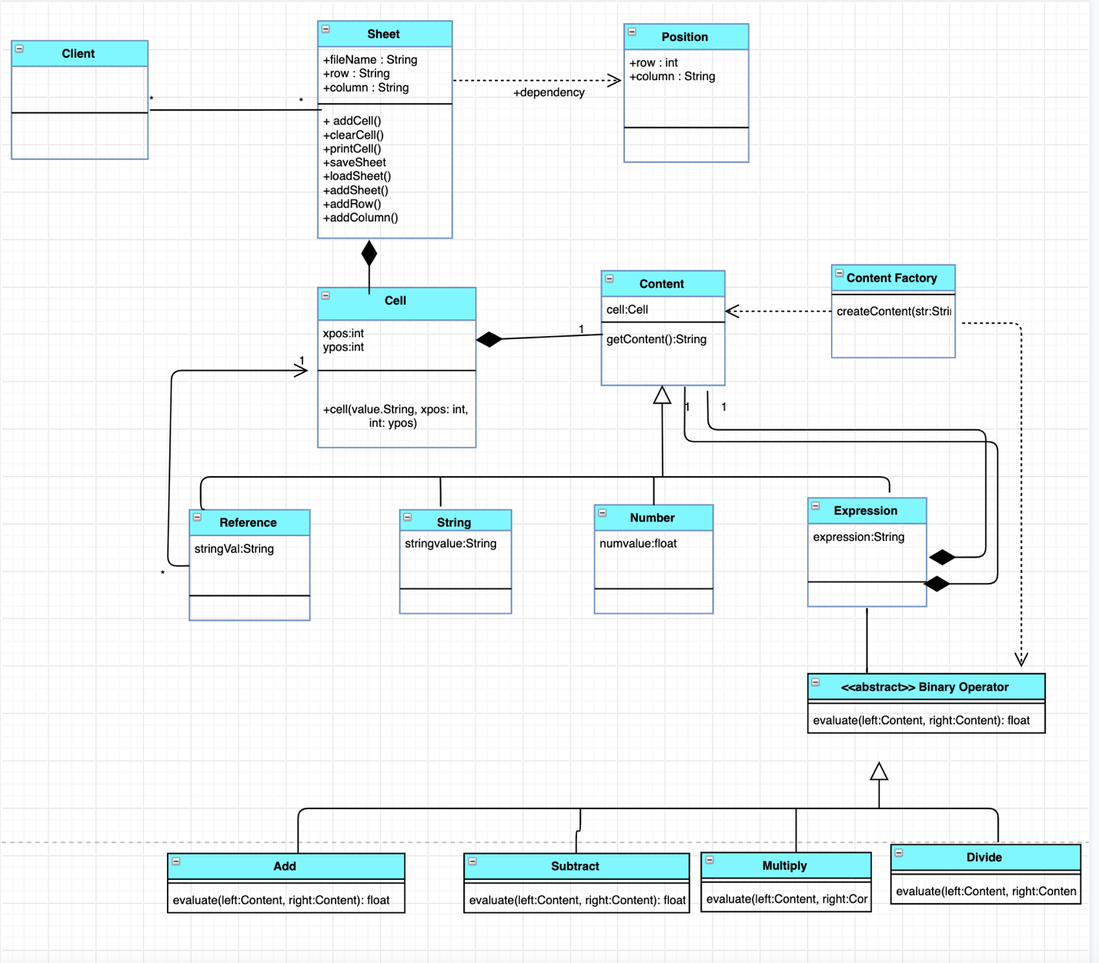

SPRINT #1 ECLIPSE

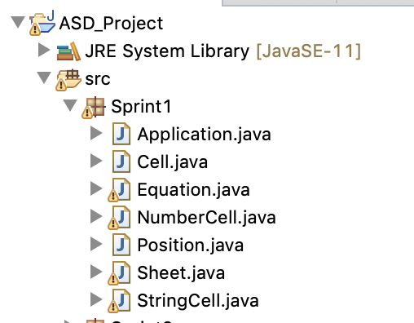

**Modeling with Design and Patterns**

**Application**

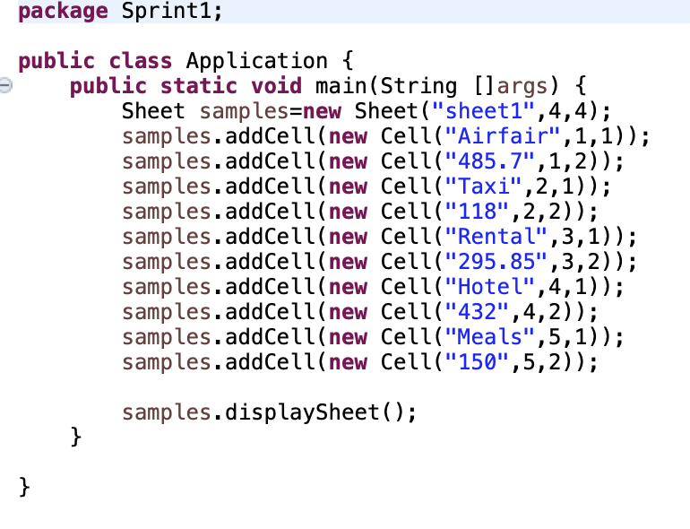

SPRINT #2 FEATURES

Sprint #2

• Numerical Value

• Reference

SPRINT #2 MODEL



SPRINT #2 ECLIPSE

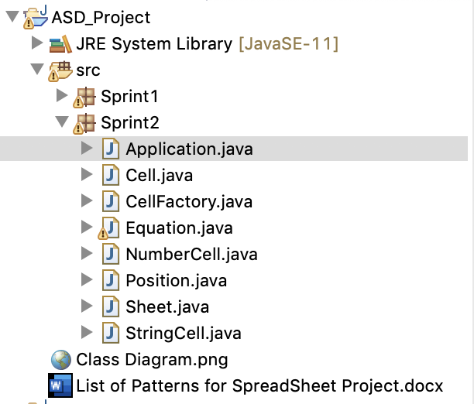

**Modeling with Design and Patterns**

**Application**

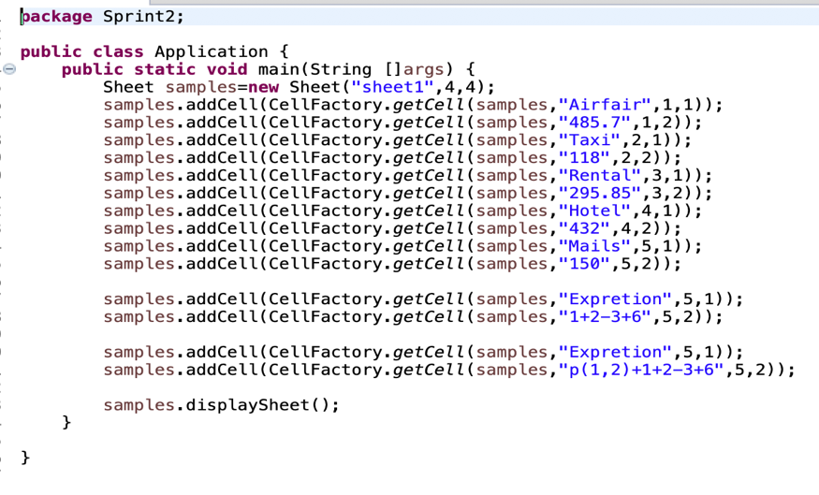

SPRINT #3 MODEL



SPRINT #3 ECLIPSE

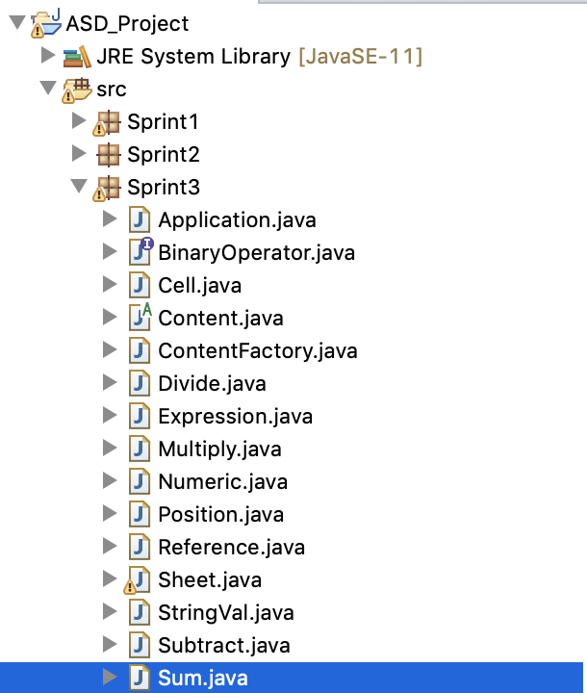

**Modeling with Design and Patterns**

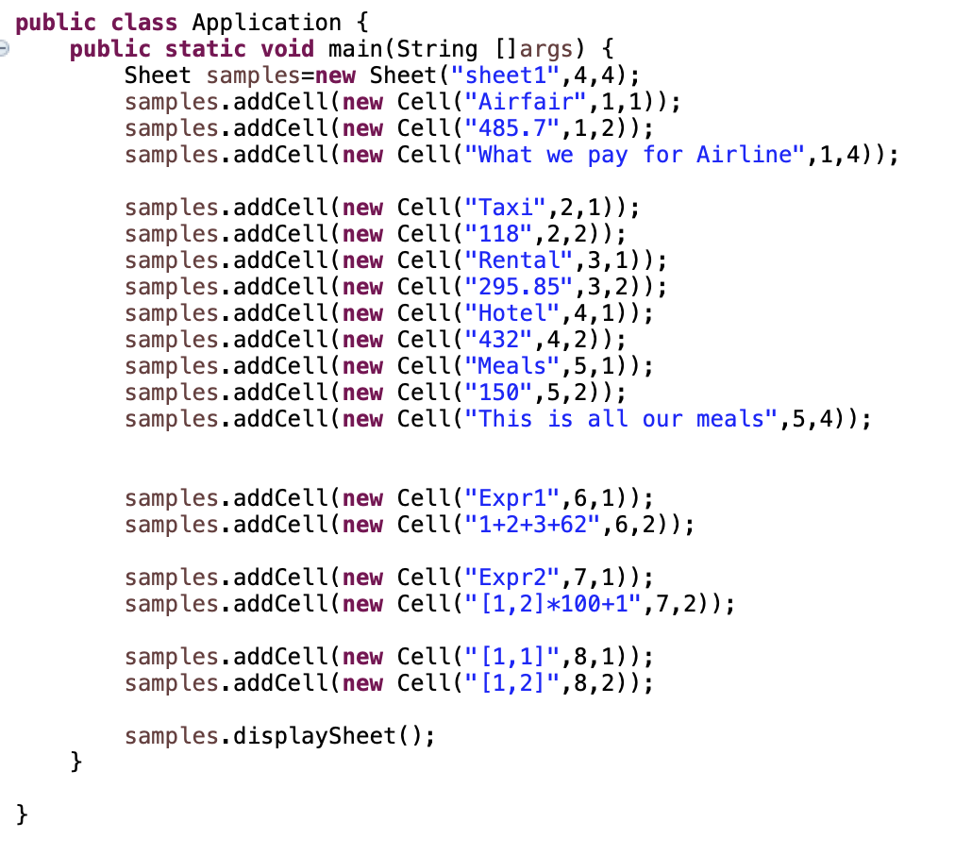

SPRINT #3 OUTPUT

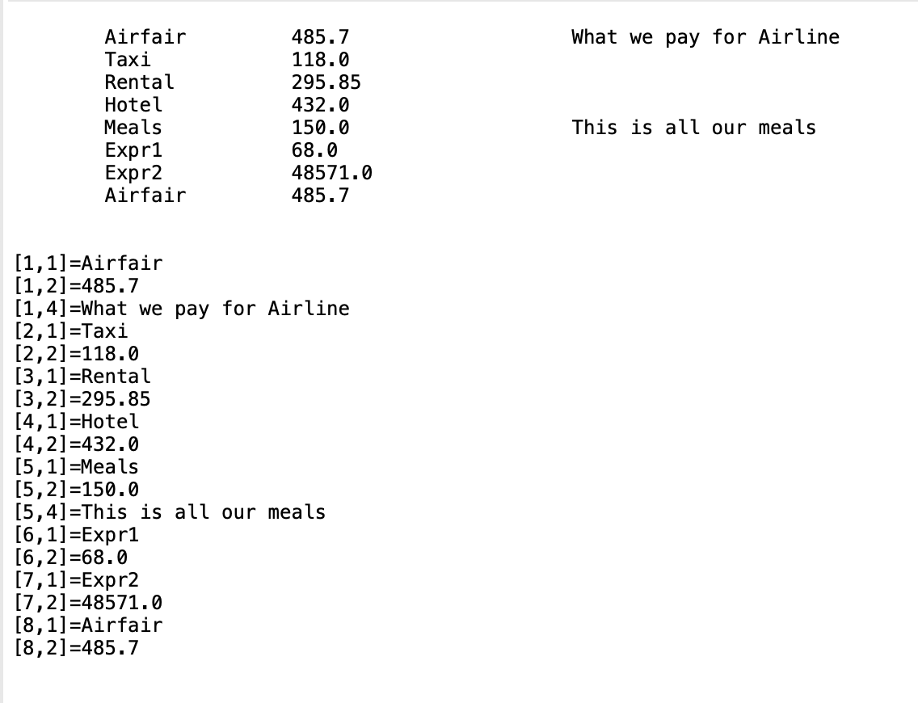

**Sprint #4, #5, #6, #7, #8. MODEL**

**# Eclipse:**

**Modeling with Design and Patterns**

**OUTPUT:**

